When option 1 is selected, it displays all enrolled students or error message is displayed, “**Students not enrolled in the institution**”.

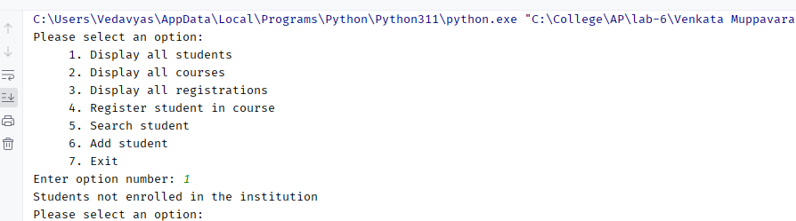

When option 1 is selected, all enrolled students are displayed in tabular format

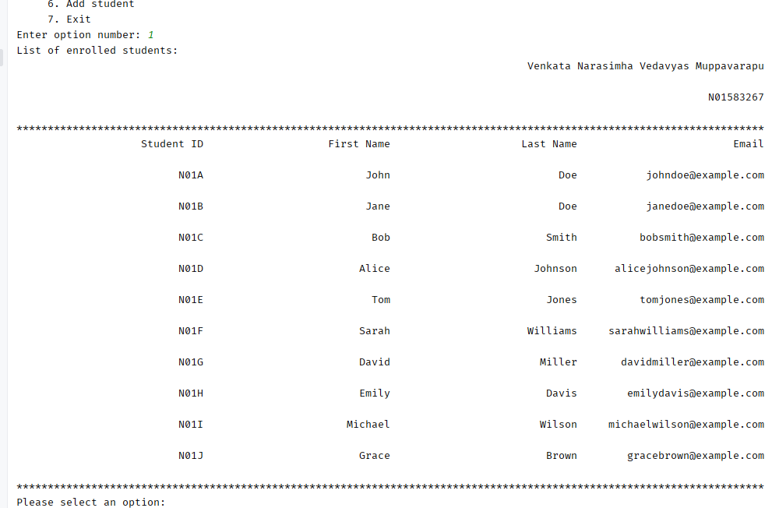

Option 2 displays the courses offered at the institution (if course list exists in the database – or an error message is displayed “**Courses not offered at the institution**”)

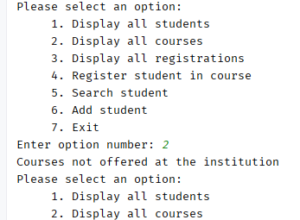

Option 2 displays all the courses offered at the institution:

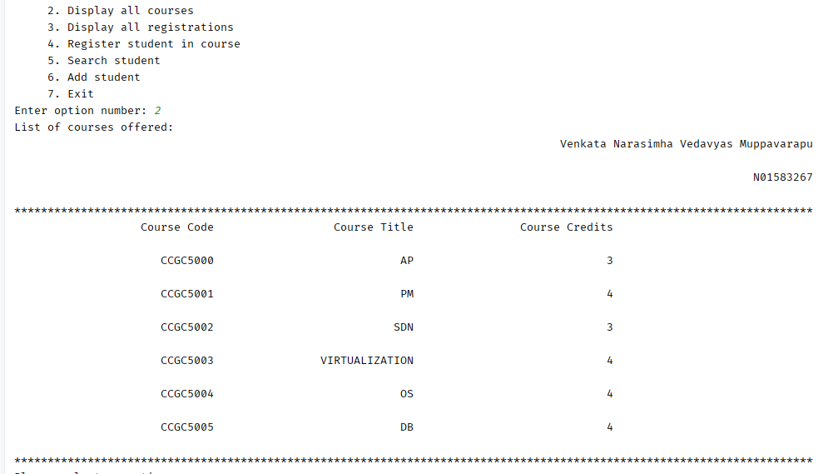

Option 3 displays the current registration in the registration table. It displays all students enrolled in different courses over the period of different semesters. If there are no students registered in any course, then course message “**There is no student registered in any course at the institution**”

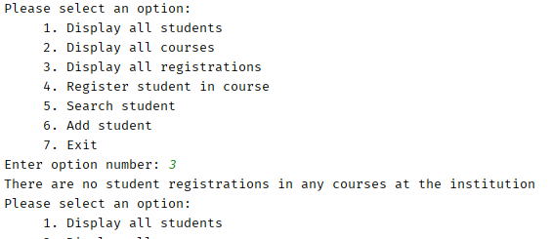

When choosing option 3, following table is displayed showing all the registrations so far:

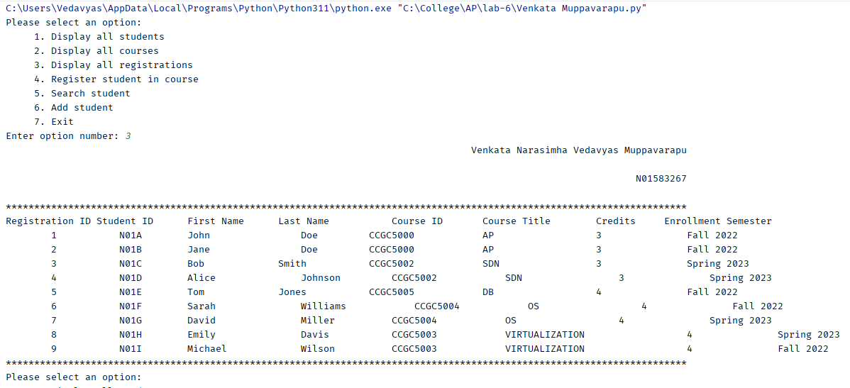

Choosing option 4 allows you to register student in a course. First the conditions are checked if student is enrolled in the institution and the course is offered at the institution, then the student is enrolled in the course.

This option (option 4) result is shown below (following shows when student is not enrolled in the institution based on student ID):

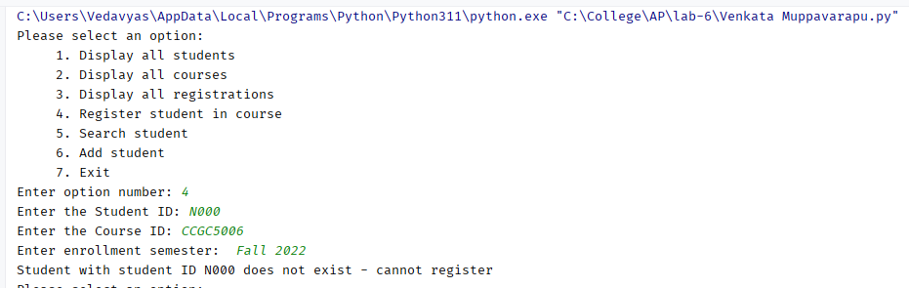

When choosing option 4, if both the student as well as the course exist, then student is enrolled in the course. This is shown below:

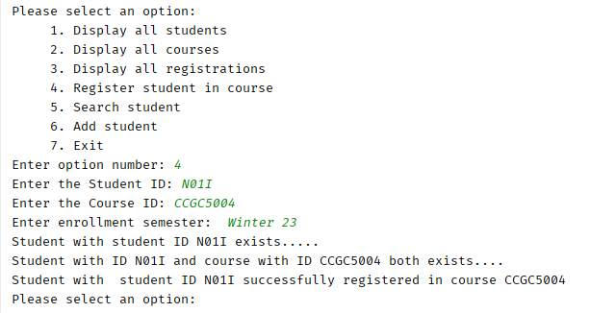

When choosing option 5, a student can be searched in the institution. Following scenario shows that when option 5 was selected and student did not exist, the message to that effect is displayed:

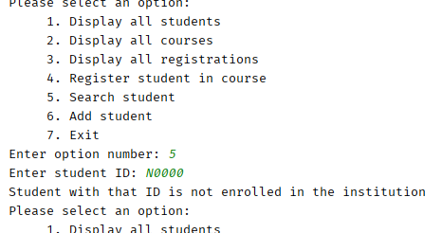

In another scenario, when student is already enrolled in the institution, the application (when choosing option 5) displays following:

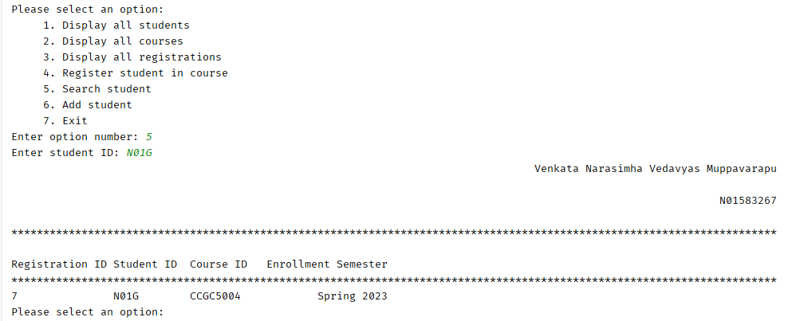

Choosing option 6 allows user to add new student in the institution – if the student is NOT already enrolled based on the student ID.

Following scenario shows that when choosing option 6, and student already exists in the institution, displays the following:

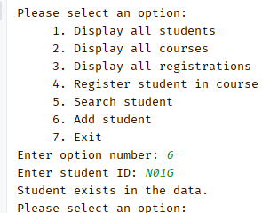

When choosing option 6, and student is not already in the system, then following message is displayed:

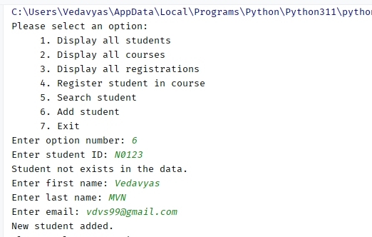

Invalid option and exiting

